Thermal Control Subsystem

The primary goal of the thermal control subsystem is to keep the components of the CubeSat — including the payload, bus, and battery — within temperature limits. The temperature of a spacecraft is determined by the amount of heat generated, stored, and dissipated by the satellite, as shown in Figure 1 (2024).

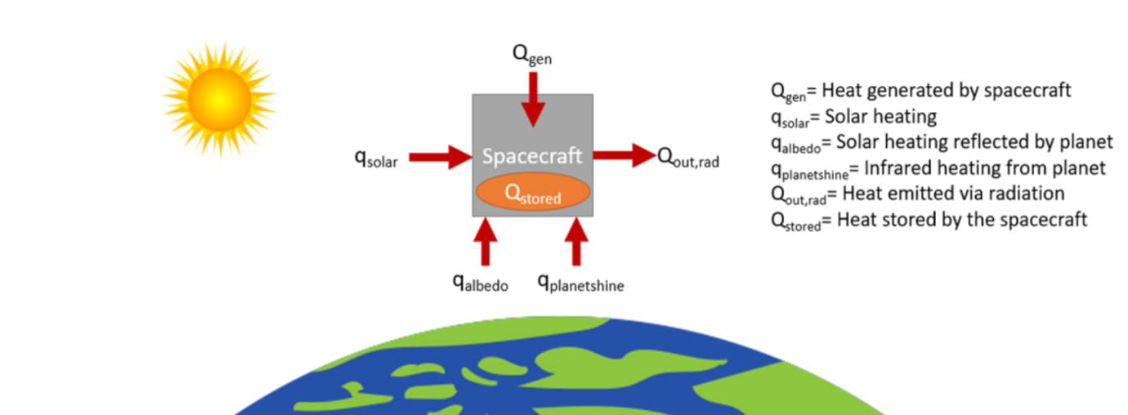

Figure : Temperature of a spacecraft

To achieve thermal control Equation 1 must be balanced.

(1)

Qgen + qsolar + qalbedo + qplanetshine = Qout,rad + Qstored

* Qgen is the heat generated by the spacecraft due to the power dissipated by its components.
* qsolar is the heat absorbed due to solar flux.
* qalbedo is the amount of reflected heat from the Earth that is absorbed.
* qplanetshine is the amount of infrared rays from the Earth that is absorbed.
* Qout,rad is the amount of heat emitted via radiation, which includes area designated for radiator space, as well as heat lost through insulation, which includes other surfaces that were not intended to act as radiators.
* Qstored is the heat stored by the spacecraft.

The thermal control subsystem for CubeSats are typically based on passive cooling methods such as surface finishes, radiators, or heat pipes (Yendler, 2021). For the SOS-CUBE, several factors, including the orbit and the operational temperatures of the payloads, must be considered. Since, the SOS-CUBE will be in a LEO orbit, in addition to solar radiation, factors such as albedo and infrared rays from the earth significantly contribute to the thermal environment (Yendler, 2021). The primary payload, QubeAIS, can withstand temperatures between -40o to +85o Celsius, whereas, the secondary payload, Triscape50, can only withstand temperatures between -10o to +50o Celsius.

The SOS-CUBE will employ a combination of passive and active thermal control methods. The conceptual design of the thermal system must include radiator design, multilayer insulation (MLI), phase change material (PCM), and louvers (Yendler, 2021). Firstly, area will be allocated for radiator panels with high emissivity coatings. The radiator panels should be pointing towards deep space to take advantage of the cold environment, maximizing heat loss and minimizing heat absorption from solar heating, albedo, and IR radiation. The electronic components are closely stacked inside the CubeSat, making it challenging to provide a path for each component to dissipate heat via the radiator. To address this issue, GFTS, which are thermal straps made of graphite, will be used to direct heat from critical components, including the camera, to the radiator (2024). Thermal straps are highly flexible, preventing the addition of structural load (2024). Moreover, heat pipes will be used to transfer heat from the other parts to the radiator.

For MLI, reinforced Tedlar will be used to provide a thin outer cover. For LEO orbit, 15 to 20 reflector layers are usually used (Finchenor, 1999), so 15 layers of aluminized Mylar will be used due to its compactness and light-weight properties (Finchenor, 1999), with Dacron netting separators. Additionally, PCMs will be placed near the electronic components and the structural panels to absorb and release heat during fluctuating temperatures. PCMs absorb a large amount of heat when it melts and releases the stored heat while it solidifies (Raoux et al., 2014). The chosen PCM is Polyethylene glycol 600 (PEG 600) which has a melting point of 20o – 25o Celsius (2024), making it suitable for SOS-CUBE. PEG 600 will be encapsulated in metallic or polymeric containers and placed near the secondary payload, TriScape50, and embedded within the structural panels. Finally, active thermal louvers will be used to regulate heat emission. Given the limited surface area for radiators and solar cells, as well as the closely stacked nature of the electronic components inside the CubeSat, these methods will ensure an efficient path for heat dissipation.

In addition to these measures, thermal sensors will be installed in the SOS-CUBE satellites to monitor the health of the components. Finally, for validating the design of the system, TVAC testing must be performed.

The SOS-CUBE’s thermal system includes a customized radiator along with a louver to manage heat dissipation effectively. The louver mechanism controls the heat rejection by opening or closing the radiator’s surface, depending on the thermal needs. This configuration helps in maintaining optimal temperature levels within the CubeSat, ensuring the components operate within their specified temperature ranges. For the radiator, MiSER was chosen. MiSER is of low cost, is lightweight, and has a precise, narrow control band for optimal heat dissipation. It operates between -130 to +100 degrees Celsius. The design consists of a flat radiator panel integrally mounted on a heat switch. It is used dissipate heat from spacecraft components such as electronics and the payloads. The radiator is mounted to the exterior of the spacecraft with the integral heat switch coupled to the heat load.

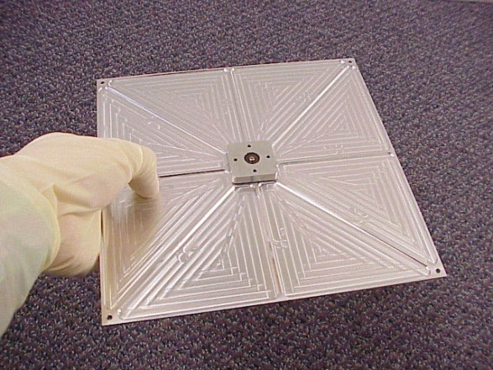

For the louver, Sierra Space’s Passive Thermal Louver that is based on decades of NASA/ Jet Propulsion Laboratory flight heritage, is used for its lightweight and simple design. It has high solar irradiance capacity, can also be customized to fit SOS-CUBE’s size requirements, and offers a wide range of operational temperature band and set points to choose from. It has a temperature band of +14 to +20 degrees Celsius and temperature set point range of -20 to +50 degrees Celsius. When the satellite's temperature rises beyond the set point, the switch conductance increases, transferring extra energy to the radiator via heat pipes and out to space. The switch conductance reduces when the satellite's temperature falls below the set-point temperature. This insulates the satellite from the colder radiator panel, allowing it to stay warm with minimal standby power. Furthermore, it is grounded to prevent electrostatic discharge (ESD) build up. The optimal effective emissivity of the louver along with the radiator is 85%.

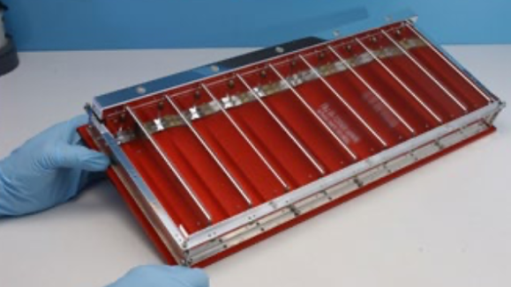

Moreover, copper thermal straps will be custom-made to direct heat from the secondary payload, TriScape50. The copper thermal strap is light-weight, and has good conductance, making it ideal for a CubeSat mission. With the help of Technology Applications, Inc. (TAI), who offer custom thermal strap designs, a thermal strap will be designed according to the dimensions of the TriScape50. The strap will be 10cms long to increase the distance to the sink which will in turn increase its conductivity. These strips efficiently transfer the heat generated by the camera to the heat sink, where it can be dissipated by the radiator.

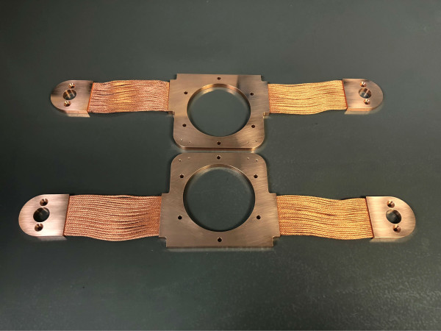

References

<https://www.nasa.gov/smallsat-institute/sst-soa/thermal-control/#7.1>

<https://www.sciencedirect.com/science/article/pii/B9780128178843000163#s0045>

<https://ntrs.nasa.gov/api/citations/19990047691/downloads/19990047691.pdf>

<https://www.sciencedirect.com/science/article/pii/B9780857098030500059>